TOP END DRUM RUNNERS (TEDR)
OFFICIAL 2025

COMPETITION RULE BOOK


WELCOME TO OUR CLUB

Thank you for being a part of our community.
Top End Drum Runners (TEDR) are 100% focused on increasing the number of participants and improving the skills and techniques of our members, whilst enhancing the overall image of barrel racing within a safe and secure environment for all involved.
For our club goals to be possible, individual competitors and guardians must abide by all rules stipulated and supported within this rule book.
Our rule book will be revised as required by our committee to include/exclude or any necessary change of rules.

DISCLAIMER:
Top End Drum Runners (TEDR) are an affiliated club with the Australian Barrel Horse Association (ABHA).
Top End Drum Runners (TEDR) adheres by the Australian Barrel Horse Association (ABHA) rule book.
Any discrepancies not covered within the Australian Barrel Horse Association (ABHA) rule book, will default to the Top End Drum Runners (TEDR) rule book and/or at the discretion of the committee.
This rule book cannot cover all possible scenarios that may arise, nor can it regulate all administrative questions.
Where a rule does not precisely regulate cases, the rules assume that the Top End Drum Runners (TEDR) Committee have the necessary sound judgement, competence and objectivity to make a ruling.

ANIMAL WELFARE

It is a requirement of Top End Drum Runners (TEDR) members that you comply with the relevant state regulations regarding animal welfare.
A current code of conduct for the welfare of animals in the Northern Territory, is available on the below NT Government website:
https://nt.gov.au/environment/animals/animal-welfare
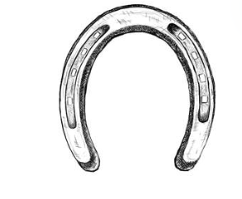
If any person/s present have concerns about the welfare of an animal on the grounds at a Top End Drum Runners (TEDR) event - MUST be reported immediately to any Committee Member of Top End Drum Runners (TEDR).
If any Committee Member have concerns about the welfare of an animal on the grounds at a Top End Drum Runners (TEDR) event, they hold the right of a majority vote to scratch or disqualify the animal and or rider from competing.
Top End Drum Runners (TEDR) recommend all competitors adhere to Racing Australia’s guidelines, for illicit substances for horse and/or rider.
Top End Drum Runners (TEDR) committee have limited horse runs to no more than 4 runs per event - exhibition runs are excluded.
Exceptions will only be applicable via a written application to the appointed committee of Top End Drum Runners (TEDR) by no later than 48 hours, prior to any event commencement.
Exceptional circumstances MUST include the appropriate evidence to litigate any risk to the horse.

HARASSMENT & BULLYING

Any Top End Drum Runners (TEDR) committee member/s, member/s, affiliates including spectators found to engaging in or attempting to engage in any action; threatening nature, berating, harassing, intimidating – including in person, telephone, email or any form of social media platform including assaulting or striking.
All complaints of Harassment and Bullying MUST be raised immediately with a committee member so the matter can be addressed promptly and appropriately.
Any form of harassment and Bullying will not be tolerated and will result in the suspension or cancellation of your Top End Drum Runners (TEDR) membership at the discretion of the Committee.
For further information, please refer to the Australian Barrel Horse Association (ABHA) rulebook.

SOCIAL MEDIA

The Top End Drum Runners (TEDR) committee does not condone the posting and boasting of any derogatory or slanderous remarks made on any social media platform by any person, member or non-member.
Any person who breaches this code of conduct will face disciplinary action or suspension by the Top End Drum Runners (TEDR) Committee.
For further information, please refer to the Australian Barrel Horse Association (ABHA) rulebook
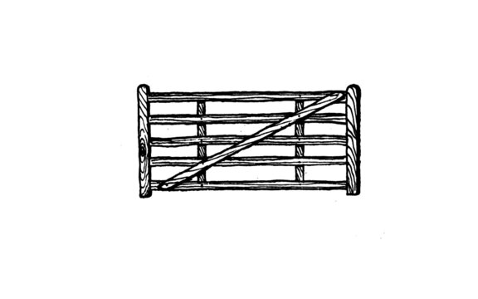

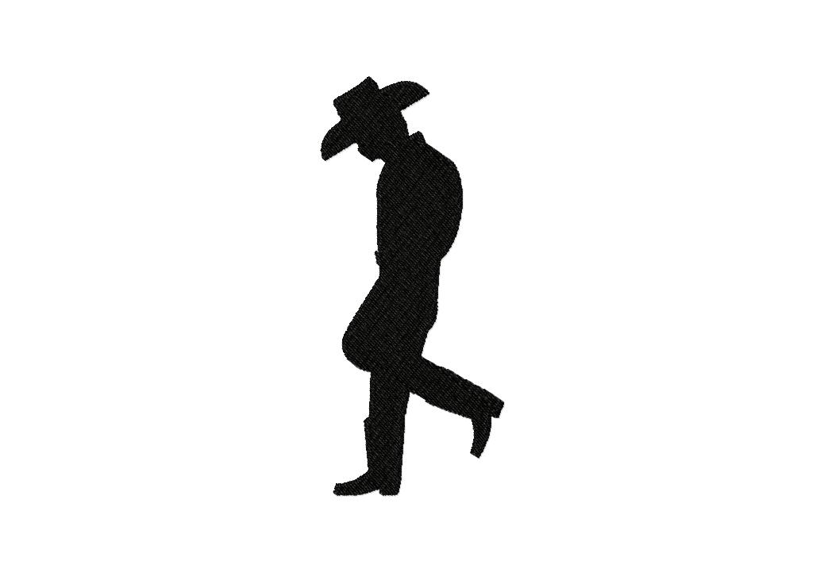
PROTESTS
Any persons who believe a rule violation or infraction has occurred at a Top End Drum Runners (TEDR) event may file a written protest.
The written protest must be accompanied by a $50 protest fee and lodged with the Committee within 48 hours of the incident that is being protested.
If the protest proves to be valid, the $50 protest fee will be returned to the person filing the protest.
If the protest proves to be invalid, the protest fee will be retained in the clubs running cost funds.
All protests will be dealt with in line with the Top End Drum Runners (TEDR) Constitution.
(NOTE: This rule does not prevent Directors and Officials from retrospectively correcting problems or errors).

COMPLAINTS
Any other complaints not covered in the above mentioned are to be put in writing within 48 hours of the incident.
You can hand deliver to a committee member or email to drumrunnersnt@hotmail.com.
These complaints will be formally addressed by the committee.

GENERAL RULES & CODE OF CONDUCT
- ALL competitors including led line support person/s, volunteers and their delegate/s must attend the compulsory RIDERS BRIEF - held approximately 30 minutes prior to the event commencing. Failure to attend the riders brief without exemption and written approval from the committee will result with the competitor unable to compete.
A written copy of the riders’ brief will be available to late competitors, volunteers and delegates upon arrival at the nomination box for acknowledgement. ALL competitors, handlers, volunteers and their delegate will be required to sign in and confirmation of attendance.

- Volunteering is compulsory - each member (or member delegate) MUST volunteer at every event for a minimum of 30 minutes.
Please message the Top End Drum Runners Facebook page by close of nominations should you have a preferred position to assist in - alternatively, you will be allocated a position.
Failure to do so will result in loss of points gained at the corresponding event. Additional people are encouraged to assist.

- ALL horses must be saddled and bridled at all times whilst being ridden anywhere on the grounds, at a Top End Drum Runners (TEDR) event. Bareback or doubling is NOT PERMITTED on the grounds, at any time.

- Riding members/day members are the only people permitted to ride horses on the grounds at a Top End Drum Runners (TEDR) event.

- ALL stallions are to be double tied whilst on the grounds at a Top End Drum Runners (TEDR) event and must be handled by a competent person over the age of 18 years.

- Consumption of illegal drugs by any person/s present at a Top End Drum Runners (TEDR) meet/s will not be tolerated. Such behavior will be reported to the Police and a suspension for the remainder of the year will be given - riders will also receive a deduction in points.

- ALL person/s attending a Top End Drum Runners (TEDR) meet or function must conduct themselves appropriately. Any individual/s displaying unacceptable and/or anti-social behaviour will be held accountable/asked to leave upon the committee’s discretion.

- Never argue with an Official, Marshall or Volunteer. Disciplinary action will be taken upon the committee’s discretion.

- Annual Membership commences from 1st January through to 31st December for a 12-month period.

- Refunds will only be applicable should the event be canceled.

SHARING OF HORSES
The sharing of a horse/s is permitted with the following conditions:
- Top End Drum Runners (TEDR) committee has limited horse runs to no more than 4 runs per event - exhibition runs are excluded.
Exceptions may apply by written application to the committee within 48 hours prior to any event. Exceptional circumstances need to warrant the application and must include evidence to litigate any risk to the horse.

- IF, it is felt by the Top End Drum Runners (TEDR) management committee that a horse is being worked too hard or that competing multiple times is having a negative impact and effect on the horse - have the right to refuse two (2) riders competing on the same horse.

AGE GROUPS
Please refer to the Australian Barrel Horse Association (ABHA) rule book for further information.

DIVISIONAL BARREL RACING RULES
- Divisional Barrel Races are not to be restricted in any manner and must be open to any rider and any horse. Divisions are determined by the affiliate of either one second or half second time bracket and Divisional times splits are to be determined by the committee based on purposes of Top End Drum Runners (TEDR) constitution prior to season commencing and communicated to members
- Junior Divisions are split at a 1 second
- Open Divisions are split at a 1 second
- Rookie Divisions are split at a minimum of 4 seconds splits
- The rookie rider category is classed on beginner rider capability, knowledge, and experience, NOT horse. Riders’ timing under 27 seconds will be transitioned to the junior or open category. It is expected you will walk, trot or canter, if appropriate, for part of the pattern, resulting in a time of over 27 seconds.
- In the divisional barrel race, the fastest clean time will be used to set divisions.
- Junior & Open Divisional – 2 run format with a 1 run format option.1 second splits with the fastest clean time will set the divisions.
Eg: 1D will be set by the fastest clean time with 2D & 3D etc being 1.0, 2.0 etc seconds off the fastest time respectively.
Rookie Riders – 2 run format with a 1 run format option. Divisions are set on the average time of the two runs. With the fastest average time setting the 1D with 2D & 3D etc divisions being 4.0, 8.0 etc seconds off the fastest average time respectively.
- Average – All rounds added together and divided by number of rounds.
- Junior and Open Divisional Purse is split evenly between the divisions.

ACCRUAL OF TOP END DRUM RUNNERS (TEDR) CHAMPIONSHIP POINTS
Top End Drum Runners (TEDR) Championship Points will be awarded in all events on a 5, 4, 3, 2, 1 basis from 1st place to 5th place.
If two or more riders tie for a position, the points for the tied position will be added together and divided equally amongst the tied riders.
All points are awarded to a rider and horse combination.

If the rider commences competing on a different horse, points are not transferred to the new horse but will remain with the previous one.
In the case of a tie for the title, a count back of the competition season to see who had the most wins at a points earning event will determine the winner.
If a tie persists - number of elevated placing’s will be considered.
In the case of a tie for a championship placing the same process will take place.
The competitor that has not won the tie from the count back review will automatically receive the next available place award.
Riders must compete at no less than four (4) meets as a full financial member to be eligible for end of year trophies/awards.
End of year Perpetual Trophy will be calculated by the highest point earner for the year in Barrels racing and Pole Bending.

DRESS CODE
It is mandatory for all competitors, led line handlers, support people and/or any other person entering the arena to be in appropriate Western attire throughout events including warm-up.

This includes:
- Long Sleeved collared shirt with sleeves rolled down and shirt buttoned.
Half button shirts are allowed; Western attire is require, please refer to the Australian Barrel Horse Association (ABHA) rule book for further guidelines.

- Helmet - all JUNIORS must always wear an Approved Australian Standards helmet whilst mounted and/or in the arena.
Approved and accepted helmets will have one of the following standards: ASNZ 3838, ASTM F1163.EN 1384 clearly identified on the helmet and must be within 5 years of manufactures date.
Helmets for Senior’s are optional however are strongly encouraged to be worn.

- A choice of cowboy hat or helmet MUST be worn by Riders over the age of 18. Support people, Volunteers and Officials over the age of 18 years in the arena must wear appropriate Western attire.

- Helmets must be worn by those under 18 years old in the arena.

- Competitors riding a horse must wear riding boots.
Led Line handlers are permitted to wear appropriate enclosed shoes - no “Crocs” are to be worn in the arena.

BARREL RACING RULES
- The Australian Barrel Horse Association (ABHA) Rule Book applies however please note; the default rule book for Top End Drum Runners (TEDR) also applies at our local meets/events and where the club committee see fit, fair and reasonable.

- For, Led Line events - refer to “Led Rein/Assisted Riders” stated in the Australian Barrel Horse Association (ABHA) Rule Book.

- It is permissible for riders to have a support person in the arena during a run however a 5 second penalty will be applicable should

the support person assist the rider in any way - once they have entered the timed competition zone (ie. If the support person touches the horse or equipment).

- The ground conditions within the arena will be monitored by the clubs committee and managed in accordance with consideration of competitor/horse safety.
Should competitors feel the arena surface is unsuitable for the safety of themselves or their horse must raise the concern to a committee member so that a reasonable solution can be found/dealt with.

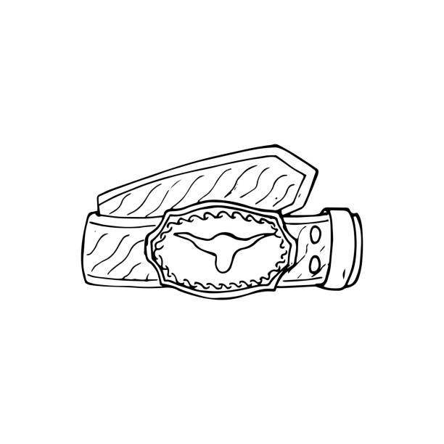
Protests, following runs - regarding surface management will not be processed due to the training ethos of the club and limited resources for surface management.

- Once in the arena the following is permitted BEFORE crossing the timer line:
  - No more than 2 circles or turns of the horse in a 360-degree movement.
  - Tail Turns or circling your horse
  - Riders can back their horse into the arena
  - Riders can walk / lead horse into the arena to mount and dismount to exit the arena - providing you do not cross the timer line
- Excessive use of a whip may result in disqualification - refer to the Australian Barrel Horse Association (ABHA) Rule Book.

POLE BENDING
Pole bending is a timed event, run in age divisions - as follows:
- Led Line
- Under 13yrs of Age
- 13 to 17 years of age
- Over 18yrs of Age

- Please refer to “Pole Bending” as stated in the Australian Barrel Horse Association (ABHA) Rule Book.
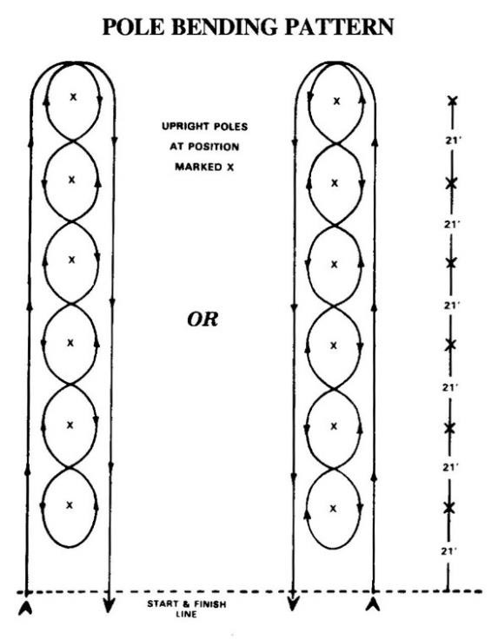
- Excessive use of a whip may result in disqualification - refer to the Australian Barrel Horse Association (ABHA) Rule Book.

DISQUALIFIFICATIONS & PENALTIES
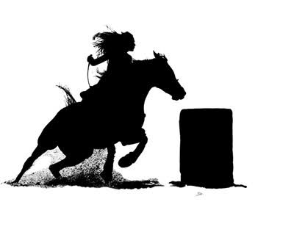
The following will result in a “No Time” being recorded:
  - Crossing the start/finish line without completing the required pattern.
  - Taking undue delay commencing the run which inhibits the run order.
  - Misidentifying a horse (ie. Riding a different horse from the one nominated).
  - Failure to be appropriately attired or failure of support person being appropriately attired.
  - Any other situation as indicated within specific event rules and the Australian Barrel Horse (ABHA) Rule Book.

The following items may result in disqualification:

- Whipping as per the Australian Barrel Horse (ABHA) Rule Book.
- Abuse of a horse in any way.
- Failing to enter the arena upon the third call by the official.
- Moving or attempting to move markers during an event.
- Use of electronic and/or remote-controlled devices to alter the outcome of a run.
- Any attempt made to hold a horse back to record a lower time in the effort to qualify for a lower division.
- Breaches of the Top End Drum Runners (TEDR) Rule Book, the Australian Barrel Horse Association (ABHA) Rule Book and or code of conduct.

Any repeated breach of the rule book or code of conduct may result in a competitor being suspended from Top End Drum Runners (TEDR) for a period, determined by the Management Committee of Top End Drum Runners (TEDR).

